JMG
Syllabus
Student email for me: hhshumphrey@gmail.com
Professional email: shumphrey@helenaschools.org
Website: hhshumphrey.com JMG Website: http://jmg.mt.gov/
Cell: (406)431-0044 School: (406)324-2246
Info You Need to Know:

1. Work is assigned daily, and all work should be completed/submitted by the due date.
2. “Homework” will not be assigned in addition to classwork, but students are expected to complete missing assignments, make up and test preparation as homework.
3. All due dates will be noted on the class website in the Lesson Plan Calendar; in your OneNote Classroom Notebook; and in PowerSchool.
-Late work is strongly discouraged as employers are rarely tolerant of late submissions of work. Therefore, unless otherwise identified by specific individual accommodation, all work will be docked 1 point for every day late. No late work will be accepted after the unit test.
4. This class uses online tools throughout. Primary tools in this class are Teams, the class website – hhshumphrey.com and OneNote Classroom Notebook, Knowledge Matters; Everfi and Mimic. Links are located on the Links Page in your notebook, on the unit page of the class website and on Teams.
5. You are expected to complete your own work and to cite the source when using the work of others. Penalties for plagiarism or cheating can be found in the Student Handbook.
6. Teams Meetings: Students who are in a quarantine or are not able to attend in person can participate in class via Teams. However, I must be notified if the student plans to attend so I can create a Team meeting.
a. Teams meetings will be cancelled if students miss the requested Teams meeting.

Grading:
Since JMG has so many projects there are two ways grading occurs.
1. Project Points: Each project has points which will be based on each student’s level of participation in a project. All students are required to participate in every project although extra credit may be given for students who go above and beyond each project.

2. Academic Grades: For those projects that are listed as academics/assessments, actual grades will be placed in the grade book as assignments are completed. It is very important that these assignments are completed. With only two or three grades, you can fail JMG, even if you get 100% worth of points.

- Projects-projects may be individual or group work. Projects are valued at 100 points. A rubric and detailed description of the expectations will be provided. In groups, students will submit a group member score for each member that will be incorporated into the final grade.

- Notebook/classwork assignments – These are assignments contained within the notebook that may include vocabulary words, calculation pages, forms, web quests, reading assignments and more. Points will be based on the number of items in the assessment. Students who are absent during completion of the assignment must complete the assignment in accordance with district policy. However, late work will be docked 1 point for each day the assignment is overdue.

- Project Management/Logging & tracking hours and completion- These assignments are based on students keeping track of hours they participate in or work on a particular project. Points will vary based on the assignment.

- Professional Dress- Every Wednesday, students may earn up to 5 extra credit points for dressing in a professional manner. More details can be found on the class website under “Professional Dress.”

- PowerSchool: While I intend to get grades in right away, grades will be posted to PowerSchool by Tuesday of the following week, at the very latest. Missing work will be noted as missing and a zero awarded.

- Grading Scale: Our grading scale is as follows:

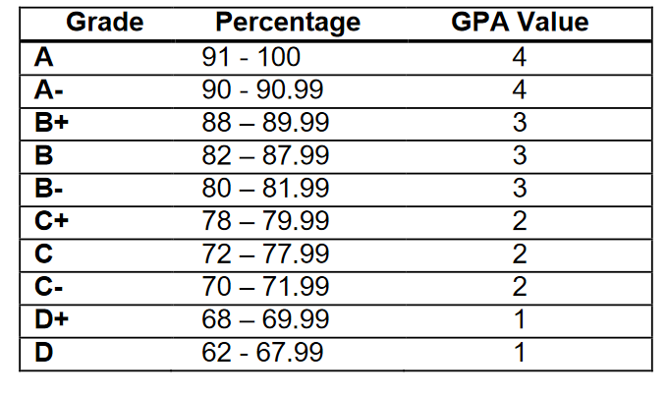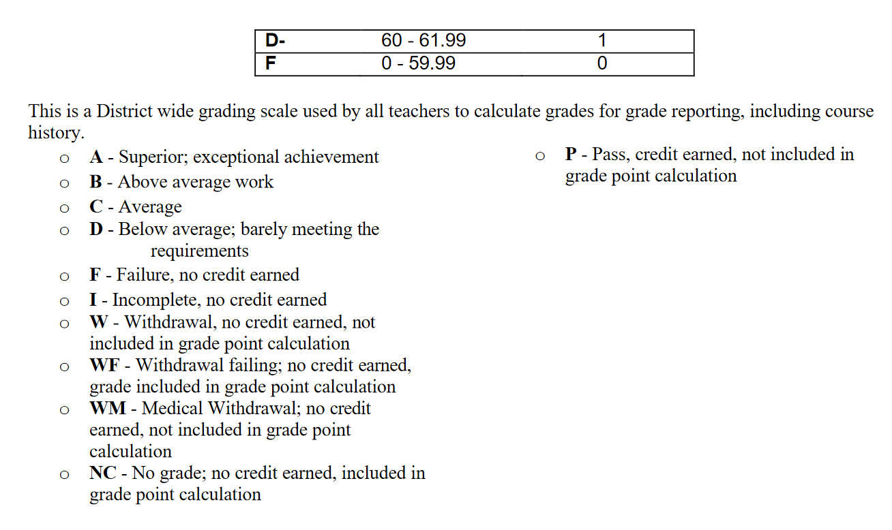

Phone Policy:
- School is a learning environment and provides preparation for college and careers. Phones provide distractions that take away from learning. Most employers report the biggest problem with young adults is failure to work without personal phone distractions. To prepare students for college and careers and to ensure they have maximum learning in my class, all students will be expected to follow the school policy regarding cell phones and listening devices. This policy states that phones and personal listening devices will be turned off or put away during class time, unless they are being used to support a lesson.

Students who fail to follow school policy, will be assigned a Yondr pouch to use during class time.

Any violation of the policy, regardless of who the student is texting/snapping/etc. will result in the student and phone being sent to the office per district policy.

- Students who need to contact a parent or answer a phone call, should simply check with me before proceeding with the text, snapchat or call.
Masks:
Students are expected to follow the mask policy mandated by our school board. Failure to follow those mandates will result in a referral to an administrator.

BENGAL EXPECTATIONS:
Our classroom rule is to Respect people, material objects and the learning environment. As an MBI school, Students are expected to Be Respectful, Be Responsible, Be Involved, and Be a Graduate. Examples include
Be Respectful
- Respect the opinions and rights of others
- Follow directions & rules
- Keep cell phone in pocket
- Dress appropriately
- Speak and act appropriately
- Follow Acceptable Use Policy for computer usage
- Value yourself and others
Be Responsible
- Be on time
- Come prepared
- Complete work as assigned or make up work right away
- Ask for support when needed
- Clean up after yourself, throw away trash and tuck in chair at the end of the class
- Log off the computer
- Upon entering classroom, log on to the computer; check your email and the lesson plan calendar; web page and then begin to work on bell ringer activity
- Keep commitments
Be Involved
- Participate in group work
- Participate in service projects
- Participate in leadership opportunities
- Participate in social activities
- Share your ideas
Be a Graduate
- Limit your absences
- Complete your work
- Set your sites on graduation and work toward it
- Realize that setbacks or obstacles are normal and work to overcome them
- Let nothing and no-one stand (including yourself) in the way of graduating on time

JMG OVERVIEW:
In order to meet the main objectives of Jobs for Montana Graduates and Jobs for America’s Graduates, specific skill development will occur in the following areas:
1. Basic Skills: Verbal, written, math and study skills
2. Teamwork and Leadership: Team membership/leadership and commitment
3. Healthy Lifestyles: Values, decision making, responsibility, positive attitudes, healthy choices
4. Career Exploration: Interests, occupation exploration, lifestyles, career goals, job shadowing
5. Find a Job: Resumes, job search, letters of application, interviewing
6. Making a difference: Community service projects, Giving back
7. Job Skills – Developing skills and competing in Business Professionals of America Workplace Skills Assessment; Business Communication Skills and Business Soft Skills.
Programs of Work include:
1. Leadership Development
2. Career Preparation
3. Social Awareness
4. Civic Development

Student Organization:
All students are members of the Montana Career Association (MCA) and members of Business Professionals of American (BPA). This allows you to attend the following conferences and participate in competitive events at the state level:
1. The Fall Leadership Conference (Officer requirement)
2. Career Development Conference (Member requirement)
3. National Student Leadership Conference (if qualified)

Unit Overview:
Activities and time frames may vary

Unit 1 – Introduction:
Approximate Time frame: 1.5 Weeks
Objectives:
At the conclusion of this unit, students will:
- Demonstrate or describe basic safety procedures
- Fire
- Earthquake
- Active Shooter/Intruder
- Evacuation route and location on practice field as well as location as off campus shelter
- Phone usage during emergencies
- Follow classroom procedures and rules including
- Logging on; using computers; saving documents and logging off; Windows 10
- District policy regarding computers and computer labs
- Classroom and district phone policy, food/drink policy; bathroom/water/leave policy; plagiarism and use of printers; Recycling; Dress code; Seating Assignment
- Accessing and utilizing class webpage
- Emailing or sharing assignments – determining preferred school email
- Ensure students can:
    - Compose, read, send, reply, and forward messages to an individual or group
    - Demonstrate the ability to create an address book for individuals and groups
    - Compose and send e-mail messages using an address book
    - Attach files to an e-mail message
    - Create folders for storing and organizing e-mail messages
    - Sort, retrieve, and delete messages
    - Use proper e-mail etiquette
    - Use snipping tool
    - Use desktop/full versions of software

- Late or make up assignments
- Behavioral Expectations – including group work
- Guiding rule - RESPECT
- Have a better understanding of their classmates and me
- Know basic content coved in the class
- Be aware of how YE dollars work
- When Professional Dress day is each week and how points are earned. (Phase 2 and 3)
- Understanding Office 365
- Using OneNote Notebook

Activities and Assessments:
- Follow business email protocol
- Introduce self to others
- Sign up for Remind
- Syllabus and class expectations quiz
- Access Moodle and OneNote Notebooks

Unit 2– Business Skills through Community Service:
Approximate Time frame: Year Long
Objectives:
At the conclusion of this unit, students will:
- Identify areas of personal interest and specific projects related to those interests
- Serve in a leadership capacity for at least one project and as a committee member for at least 3 projects per quarter and team member on all projects
- Demonstrate computer skills using Microsoft products: Outlook, OneNote, Excel and Word
- Develop and use marketing techniques to increase sales or support for projects
- Research specific needs, information and details related to each project
- Produce a public artifact whether a fundraiser, event or informational activity
- Participate in projects reviews and reflection and make recommendations for similar and future projects

Unit 3– Business Skills through Community Service:
Approximate Time frame: Year Long
Objectives:
At the conclusion of this unit, students will:
- Identify areas of personal interest and specific projects related to those interests
- Serve in a leadership capacity for at least one project and as a committee member for at least 3 projects per quarter and team member on all projects
- Demonstrate computer skills using Microsoft products: Outlook, OneNote, Excel and Word
- Develop and use marketing techniques to increase sales or support for projects
- Research specific needs, information and details related to each project
- Produce a public artifact whether a fundraiser, event or informational activity
- Participate in projects reviews and reflection and make recommendations for similar and future projects

Project Overview: (subject to change based on project time constraints and student project choices):
1st Quarter:
Projects are chosen by students but could include:
- Campaign for JMG Office
- Initiation and Installation Ceremony for all JMG members
- Think Pink T-Shirt sales/fundraising and Event Planning
- Nami Walk
- Food Drive
- Fall Leadership Conference
- Halloween
- Courtyard clean up and Decorate
- Veteran/Military Appreciation
- Other fundraising or projects based on school needs
Academics/Assessments:
- Career Portfolio
- Career Poster or Research Paper
- Dress for Success
- On the Job Success
- Workplace Assessment and Skills Program (Business Skills)
- Determine Project
- Email Activity
- All About Me
- Project Planning
2nd Quarter:
Projects are chosen by students but could include:
- Native American Month
- Festival of Tress for Intermountain
- Special Olympics
- Blankets/Toys for Shodair
- Toys for Tots
- One Warm Coat Drive
- Thanksgiving Basket
- Christmas Basket
- Winter Social
- Maredy or other fundraiser
- Courtyard Clean up/Decorate
- Homeless Project
Academics/Assessments:
- Business Skills Project – uses Business Professionals of America Workplace Skills Program
- Job Shadows
- Business Communications: Emails, Telephone Skills; Email Etiquette
- Resumes, Cover Letters, Interviews

3rd Quarter:
Projects are chosen by students but could include:
- 8th Grade Tours
- Cookie dough Sales
- Job Shadow
- Pennies for Patients
- Valentine’s Project and Sales
- 4Oceans
- Sunshine Boxes
Academics/Assessments:
- Money Management/Personal Finance
- Conover Workplace Readiness Certification
- Leadership Training
4th Quarter:
Projects are chosen by students but could include:
- Career Fair
- State Ignite Conference
- Courtyard Clean up/Decorate
- Graduates’ Celebration
- Career Day at HMS
Academics/Assessments:
- Healthy Lifestyles – dealing with Stress
- Goal Setting
- Competition as a Success Tool

