**Python Turtle Graphics Section 3**

**Python Reading (30 total pts)**

Read [Python Turtle Graphics](http://interactivepython.org/runestone/static/thinkcspy/toc.html) from the section entitled *Iteration Simplifies our Turtle Program* through the section entitled *The range Function*.

**Check Your Understanding**

1. Create code to draw a square spiral using Turtle Graphics. An example of a square spiral is:

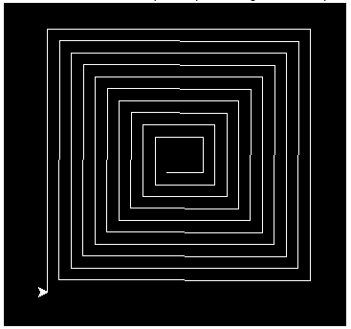

1. Code Exercise 10 at the bottom of this chapter.

**Useful Information**

* You can let the user exit a window with the command *wn.exitonclick()*
* The range function comes in three varieties: *range(stop)* and *range(start, stop)* and *range(start, stop, step) and you can nest one range() inside another*
* *penup(), pendown(), stamp(), shape() and backward() are very useful for #10*[*Turtle Methods*](https://docs.python.org/3/library/turtle.html)